**The Stroop Task**

**Experiment**

In a Stroop task, participants are presented with a list of words, with each word displayed in a color of ink. The participant’s task is to say out loud the *color of the ink* in which the word is printed. The task has two conditions: a congruent words condition, and an incongruent words condition. In the ***congruent*** *words* condition, **the words being displayed are color words whose names match the colors in which they are printed**: for example RED, BLUE. In the ***incongruent*** *words* condition, **the words displayed are color words whose names do not match the colors in which they are printed**: for example PURPLE, ORANGE. In each case, we measure the time it takes to name the ink colors in equally-sized lists. Each participant will go through and record a time from each condition.

**Experiment Statistics**

The experiment is performed on a set of participants for both congruent and incongruent word conditions. And the sample time and difference in times were recorded. With this experiment we try to figure out if there is a significant difference between time taken to read aloud the names of colors the words are printed in for congruent and incongruent words.

**Independent variable**: Color of the words

**Dependent variable**: Time taken to read aloud the color of word

Initial Data from Experiment

|  |  |  |
| --- | --- | --- |
| Congruent (T1) | Incongruent (T2) | T1 - T2 |
| 12.079 | 19.278 | -7.199 |
| 16.791 | 18.741 | -1.95 |
| 9.564 | 21.214 | -11.65 |
| 8.63 | 15.687 | -7.057 |
| 14.669 | 22.803 | -8.134 |
| 12.238 | 20.878 | -8.64 |
| 14.692 | 24.572 | -9.88 |
| 8.987 | 17.394 | -8.407 |
| 9.401 | 20.762 | -11.361 |
| 14.48 | 26.282 | -11.802 |
| 22.328 | 24.524 | -2.196 |
| 15.298 | 18.644 | -3.346 |
| 15.073 | 17.51 | -2.437 |
| 16.929 | 20.33 | -3.401 |
| 18.2 | 35.255 | -17.055 |
| 12.13 | 22.158 | -10.028 |
| 18.495 | 25.139 | -6.644 |
| 10.639 | 20.429 | -9.79 |
| 11.344 | 17.425 | -6.081 |
| 12.369 | 34.288 | -21.919 |
| 12.944 | 23.894 | -10.95 |
| 14.233 | 17.96 | -3.727 |
| 19.71 | 22.058 | -2.348 |
| 16.004 | 21.157 | -5.153 |
|  |  |  |
|  | Sample Average | -7.964791667 |
|  | Sample Standard deviation | 4.86482691 |
|  | N | 24 |
|  | Degree of Freedom | 23 |

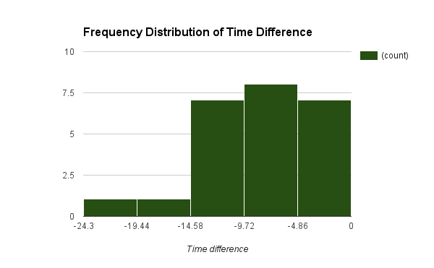

The graph above shows frequency distribution of time difference of the sample data. Participants of the sample on an average take 7.96 seconds more to read aloud the color of incongruent words than congruent words, with a variation of 4.86 seconds. The histogram is negatively skewed as all the participants in sample take more time to pass the incongruent words test than congruent words test.

Average time taken by participants for congruent words = Muc = 14.05 seconds

Average time taken by participants for incongruent words = Mui = 22.01 seconds

**Null Hypothesis**: Time taken to read aloud the color of congruent set of words is the same as time taken to read aloud the color of incongruent set of words

Ho: Muc = Mui (or Ho: Muc – Mui = 0)

**Alternate Hypothesis**: Time taken to read aloud the color of congruent set of words significantly differs from time taken to read aloud the color of incongruent set of words.

Ha: Muc <> Mui (or Ha: Muc - Mui <> 0)

**Point estimate** = Muc – Mui = -7.96 seconds

Since every participants is asked to take both test and the task does not mention whether it will take higher or lower amount of time to read incongruent words color, hence with no sense of direction we will perform a two tailed T test for dependent samples(for 95% confidence).

**Two tailed T test for dependent samples details**

Sample size is 24

Degree of freedom = 23

For an alpha value of 0.05 (95% confidence) the T critical values are +2.069

Point estimate = -7.96

Sample standard deviation = 4.86

**T statistic** = -7.96/(4.86/sqrt(24)) = -8.02

**Decision**

Since the t statistic is way smaller than t critical values for sample size, the probability of this sample mean is by chance is very low (Less than 0.0001). Hence we **Reject the Null** hypothesis.

So by our alternate hypothesis,

**Time taken to read aloud the color of congruent set of words significantly differs from time taken to read aloud the color of incongruent set of words.**

**Ha: Muc <> Mui (or Ha: Muc - Mui <> 0)**

As this was an experimental design we can say that the congruency of words had a causal effect on the Time taken to read the words.

**Effect size measure**

**Cohen’s d** = -7.96/4.86 = -1.64

Confidence Interval for population mean = (-7.96 –(2.069*(4.86/sqrt(24))), -7.96 +(2.069*(4.86/sqrt(24))))

= (-10.02,-5.91)

By the control interval on an average participants will take about 5 to 10 seconds less to read congruent word color than incongruent word color.

Personal Score as participant

|  |  |
| --- | --- |
| Congruent words | 19.08 |
| Incongruent words | 40.231 |

Yes the results did match up with my expectations; there was a significant difference between time taken to read congruent words and incongruent words. I took about 20 seconds less in reading the congruent words than incongruent words.

**Explanation:**

The words themselves have a strong influence over your ability to say the color. The interference between the different information (what the words say and the color of the words) your brain receives causes a problem. There are two theories that may explain the Stroop effect:

* Speed of Processing Theory: the interference occurs because words are read faster than colors are named.
* Selective Attention Theory: the interference occurs because naming colors requires more attention than reading words.

Some similar tasks could be

* Read words of one language written in script of another language
* Read negative Vs positive emotion/motivating words
* Read the words upside down or inside out or rotated on an angle
* Read non sense words
* Read long and short words
* Read words that are split colored

Link to spreadsheet

<https://docs.google.com/spreadsheets/d/1e9aWP-7Ebh3UTpuy5kHuII3hoaWrbRM5fVUHXdGq174/edit?usp=sharing>